SIMATS ENGINEERING
ASSESSMENT TOOL 1
COURSE NAME: CSA16 COURSE CODE: Data Warehousing and Data Mining
COURSE OUTCOME COVERED
CO2: Apply suitable Data Pre processing techniques like Data cleaning, Data intergration,Data transformation and data Reduction , for effective data preparation (BL3,BL4)

QUESTIONS: 5 Total Marks:50
Annexure B
Analytical Problem Solving
Criteria | Problem Understandin  g (2) | Method  Selection  (2) | Solutio n Process  (2.5) | Accuracy of  Calculation  (2) | Interpretation of Results  (1.5) | Total(10  )
Weightag  e | 20% | 20% | 25% | 20% | 15% | 100%
Q1
Q2
Q3
Q4
Q5
Code of Conduct:
I SK RAHAMATH ALI (192365048) (Name / Reg No) certify that this submission is my original work and that I have adhered to the guidelines specified for this assessment.
I understand that any violation of academic integrity rules will result in disciplinary action.
Signature of the student:
RUBRICS FOR CALCULATION:
 |  | Numerical Problems
Criteria | Weightage | Level 4 (Exemplary) | Level 3 (Proficient) | Level 2 (Developing) | Level 1 (Beginning)
Problem Understanding | 20% | Clearly interprets problem,  identifies all  parameters and  requirements  accurately | Understands problem with minor gaps | Partial understanding; misses key elements | Misinterpret s or unable  to  understand problem
Method Selection | 20% | Selects most appropriate  method/formula with strong justification | Selects correct method with minor errors | Inappropriate or partially correct method | Unable to select  method
Solution  Process | 25% | Logical, systematic steps with correct approach throughout | Mostly correct steps with minor mistakes | Disorganized steps; multiple errors | No clear process
Accuracy of  Calculation | 20% | All calculations accurate; correct final answer | Minor calculation errors | Frequent errors; incorrect final answer | No valid calculations
Interpretation of  Results | 15% | Clearly interprets results with units  and engineering relevance | Basic interpretation  with minor omissions | Limited or unclear interpretation | No interpretatio n
Annexure B
Analytical Problem Solving
1. Missing Value Imputation using Mean Method (Hospital Patient Records)
(5
Marks)
A hospital maintains records of patients' fasting blood sugar levels (mg/dL). Some values are missing due to equipment malfunction.
Blood Sugar Levels (mg/dL):
95, 102, 110, –, 120, 115, 108, –, 130, 125 Perform the following:
Calculate the mean of the available observations.
Replace the missing values using the mean imputation method.
Write the completed dataset.
  - Min–Max Normalization of Cholesterol Levels (Healthcare Analytics) (5 Marks) A health insurance company normalizes cholesterol values before clustering customers.
Cholesterol Levels (mg/dL):
160, 180, 200, 220, 240, 260
Normalize the data into the range [0,1] using Min–Max normalization. Show all calculations.
  - Decimal Scaling Normalization of Annual Medical Expenses (10 Marks)
A medical insurance provider records the following annual treatment expenses (₹):
8500, 12000, 15000, 18000, 22500, 30500, 47000 Perform decimal scaling normalization.
- Determine the value of .
- Normalize each observation.
- Explain why decimal scaling is useful in data preprocessing.
- Correlation Analysis between Exercise Hours and BMI (10 Marks)
A wellness program records weekly exercise hours and Body Mass Index (BMI) for five members.
Exercise Hours (x) BMI (y)
2 31
    - 29
    - 28
    - 26
8 24
Perform the following:
- Calculate the mean of x and y.
- Compute the Pearson correlation coefficient.
- Interpret whether the relationship is positive, negative, or weak.
- Equal-Depth Binning using Bin Means (Patient Waiting
Time) (5 Marks) A hospital records patient waiting times (minutes).
Sorted Data:
10, 12, 15, 18, 20, 22, 25, 28, 30, 35, 40, 45 Partition the data into 4 equal-frequency bins.
Replace every value in each bin by the mean of the corresponding bin.
Write the smoothed dataset.

1.Missing Value Imputation using Mean Method (Hospital Patient
Records)
Given Data
Blood Sugar Levels (mg/dL):
StepAvailable 1: Calculate _{observations}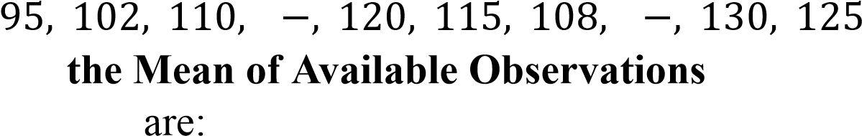 Number of available95 observations:, 102, 110, 120 , 115, 108, 130, 125
Sum of available observations: 𝑛 = 8
Mean∑ 𝑋 =_{formula:}95 + 102 + 110 + 120 + 115 + 108 + 130 + 125∑ 𝑋 = 905
∑𝑋
Substituting the values: 𝑋 = ^{𝑛}
Therefore, 𝑋 = ⁹⁰⁵8 𝑋 = 113. 125 𝑚𝑔/𝑑𝐿
Step 2: Replace the Missing𝑀𝑒𝑎𝑛 Values= 113 . 125 𝑚𝑔/𝑑𝐿
Missing values: 𝑋4 = 113. 125, 𝑋8 = 113. 125
Step 3: Completed Dataset
_{Final Answer}95, 102 , 110, 113. 125, 120, 115, 108, 113. 125, 130, 125
Mean of available observations:
Missing values after Mean Imputation:113. 125 𝑚𝑔/𝑑𝐿
Completed _{Dataset:} 113. 125, 113. 125
95, 102, 110, 113. 125, 120, 115, 108, 113. 125, 130, 125
Result:
The missing blood sugar values were successfully replaced using the Mean Imputation Method, resulting in a complete dataset suitable for further analysis.

2.Min–Max Normalization of Cholesterol Levels (Healthcare Analytics) Given Cholesterol Levels (mg/dL): 160, 180, 200, 220, 240, 260
Step 1: Find the Minimum and Maximum Values Minimum value:
Maximum value: 𝑋𝑚𝑖𝑛 = 160 𝑋𝑚𝑎𝑥 = 260
Step 2: Apply the Min–Max Normalization Formula The Min–Max normalization formula is:
Substituting the values: 𝑋' = 𝑋𝑚𝑎𝑥𝑋−−𝑋𝑚𝑖𝑛𝑋𝑚𝑖𝑛
𝑋' = 260𝑋−−160160 𝑋' = 𝑋−100160
Step 3: Normalize Each Value
For 160 𝑋' = 160100−160 = 1000 = 0. 00
For 180
𝑋' = 180100−160 = 10020 = 0. 20

For 200 𝑋' = 200100−160 = 10040 = 0. 40
For 220 𝑋' = 220100−160 = 10060 = 0. 60
For 240 𝑋' = 240100−160 = 10080 = 0. 80
For 260 𝑋' = 260100−160 = 100100 = 1. 00
Normalized Dataset
Original Cholesterol (mg/dL) Normalized Value
160 | 0.00
180 | 0.20
200 | 0.40
220 | 0.60
240 | 0.80
260 | 1.00

Final Answer
Normalized Cholesterol Levels
^{Result} 0. 00, 0. 20, 0. 40, 0. 60, 0. 80, 1. 00
The cholesterol values have been successfully normalized to the range [0,1] using the Min–Max Normalization method. These normalized values are suitable for clustering and other machine learning algorithms.

3.Decimal Scaling Normalization of Annual Medical Expenses
Given Data
Annual Medical Expenses (₹): 8500, 12000, 15000, 18000, 22500, 30500, 47000
Step 1: Determine the Value of
The decimal scaling normalization𝑗 formula is:
where, 𝑋' = ¹⁰𝑋𝑗
● = Original value
●● 𝑋𝑋='₌ _{Smallest} Normalized _{integer} value _{such} that the maximum normalized value is less than
1.𝑗
The maximum expense is:
Since, 𝑋𝑚𝑎𝑥 = 47000
So, 𝑗 = 4is not sufficient. 47000÷104 = 4. 7 (> 1)
Next,
Therefore, 47000÷105 = 0. 47 (< 1)
𝑗 = 5
Step 2: Normalize Each Observation Using the formula:
For ₹8500 𝑋' = ¹⁰𝑋5
𝑋' = 100000⁸⁵⁰⁰ = 0. 085
For ₹12000 𝑋' = 100000¹²⁰⁰⁰ = 0. 120
For ₹15000
𝑋' = 100000¹⁵⁰⁰⁰ = 0. 150
For ₹18000 𝑋' = 100000¹⁸⁰⁰⁰ = 0. 180
For ₹22500 𝑋' = 100000²²⁵⁰⁰ = 0. 225
For ₹30500 𝑋' = 100000³⁰⁵⁰⁰ = 0. 305
For ₹47000 𝑋' = 10000047000 = 0. 470
Normalized Dataset
Annual Medical Expense (₹) Normalized Value
8500 0.085
12000 0.120
15000 0.150
18000 0.180
22500 0.225
30500 0.305
47000 0.470

Step 3: Why is Decimal Scaling Useful in Data Preprocessing?
Decimal scaling normalization is useful because:
- It scales all numerical values to a smaller range by moving the decimal point.
- It preserves the relative order of the data.
- It prevents large values from dominating machine learning algorithms. ● It improves computational efficiency and numerical stability.
- It is simple to implement and useful for datasets containing values with different magnitudes.

Final Answer
- Value of 𝑗 𝑗 = 5
- Normalized Values
- ^{Conclusion}0. 085, 0. 120, 0. 150, 0. 180, 0. 225, 0. 305, 0. 470
Decimal scaling normalization converts the annual medical expenses into smaller values by dividing each observation by 10⁵. This ensures that all normalized values are less than 1 while maintaining their proportional relationships, making the data suitable for preprocessing and machine learning applications.

4.Correlation Analysis between Exercise Hours and BMI
Given Data
Exercise Hours (x) BMI (y)
2 31
- 29
- 28
- 26
8 24

Step 1: Calculate the Mean of and

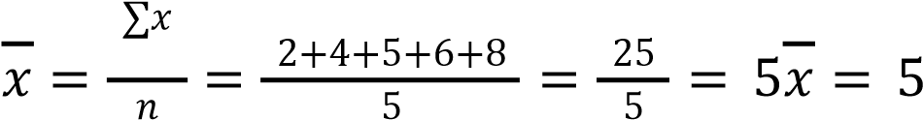
Mean of Exercise Hours (𝑥) 𝑥 𝑦
Mean of BMI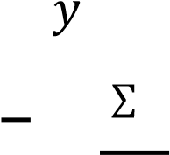 ( )
𝑦 = 𝑛𝑦 = 31+29+285 +26+24 = 1385 = 27. 6𝑦 = 27. 6
Step 2: Compute the Pearson Correlation Coefficient
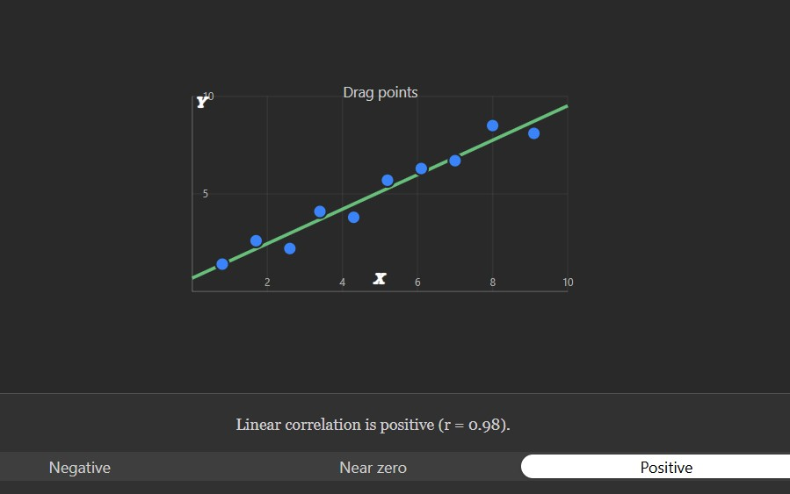
The Pearson correlation coefficient is given by:
𝑟
=
∑
(
𝑥
−
𝑥
)
𝑦
−
𝑦
(
)
∑
(
𝑥
−
𝑥
)
2
×
∑
(
𝑦
−
𝑦
)
2
Calculation

Table

x

y

𝑥
−
𝑥
𝑦
−
𝑦
𝑥
−
𝑥
(
)
𝑦
−
𝑦
(
)

𝑥
−
𝑥
(
)
2

𝑦
−
𝑦
(
)
2
2

31

-3

3.4

-10.2

9

11.56

4

29

-1

1.4

-1.4

1

1.96

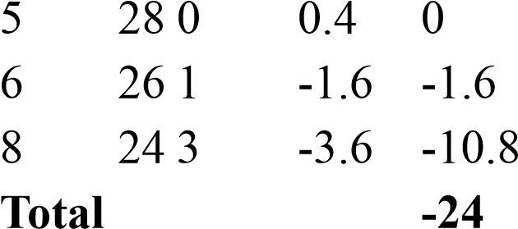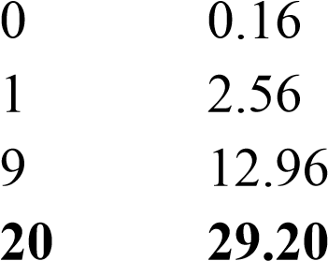

Substitute into the Formula
𝑟 = 20⁻×²⁴29.20 𝑟 = ⁻584²⁴ 𝑟 = 24⁻.²⁴166 𝑟 =− 0. 993𝑟≈ − 0. 993
Step 3: Interpretation
The Pearson correlation coefficient is:
Since the value of 𝑟is very close to𝑟 −1=−, there0. 993 is a very strong negative
correlation between exercise hours and BMI.
Interpretation: As the number of weekly exercise hours increases, the BMI tends to decrease.

Final Answer
- Mean Values

- Pearson Correlation Coefficient𝑥 = 5, 𝑦 = 27. 6
- Interpretation 𝑟≈ − 0. 993
  - The correlation is negative.
  - The relationship is very strong negative.
  - Conclusion: Members who exercise more hours per week generally have a lower BMI.

5.Equal-Depth Binning using Bin Means (Patient Waiting Time)
Given Data (Sorted) Total number of10 observations:, 12, 15, 18 , 20, 22, 25, 28, 30, 35, 40, 45
Number of bins: 𝑛 = 12
Each bin contains: 𝑘 = 4 ¹²4 = 3 𝑜𝑏𝑠𝑒𝑟𝑣𝑎𝑡𝑖𝑜𝑛𝑠

Step 1: Partition the Data into 4 Equal-Frequency Bins
Bin Data
Bin 1 10, 12, 15
Bin 2 18, 20, 22
Bin 3 25, 28, 30
Bin 4 35, 40, 45

Step 2: Calculate the Mean of Each Bin Bin 1 Data:
Mean: 10, 12, 15
10+123 +15 = 373 = 12. 33
Bin 2 Data:
Mean: 18, 20, 22
18+203 +22 = 603 = 20
Bin 3 Data:
Mean: 25, 28, 30
25+283 +30 = 833 = 27. 67
Bin 4 Data:
Mean: 35, 40, 45 35+403 +45 = 1203 = 40
Step 3: Replace Every Value in Each Bin by the Bin Mean
Bin 1
After smoothing: | 10, 12, 15
Bin 2 | 12. 33, 12. 33, 12. 33
After smoothing: | 18, 20, 22
Bin 3 |  | 20, 20, 20
After smoothing: |  | 25, 28, 30
Bin 4 |  | 27. 67, 27. 67, 27. 67
After smoothing: |  | 35, 40, 45
Smoothed Dataset |  | 40, 40, 40
12. 33, 12. 33, 12. 33, 20, 20, 20, 27. 67, 27. 67, 27. 67, 40, 40, 40
Final Answer
- Equal-Frequency Bins
  - Bin 1: 10, 12, 15
  - Bin 2: 18, 20, 22
  - Bin 3: 25, 28, 30
  - Bin 4: 35, 40, 45
- Bin Means
  - Bin 1 Mean = 12.33 ● Bin 2 Mean = 20
  - Bin 3 Mean = 27.67
  - Bin 4 Mean = 40
- Smoothed Dataset
^{Result}12 . 33, 12. 33, 12. 33, 20, 20, 20, 27. 67, 27. 67, 27. 67, 40, 40, 40
The patient waiting times were successfully partitioned into 4 equal-frequency bins, and each value was replaced by the mean of its corresponding bin, resulting in the smoothed dataset shown above.

